Title of presentation/poster; Style: Title,

preferred font size: 24pt, acceptable: 22-28pt

Authors (without affiliation)

Name SURNAME, Name SURNAME, Name SURNAME

Corresponding Author: Name Surname, e-mail; style: Heading 3

Short description of researches or project assumptions should be included (style: Normal)
MAXIMUM 10 lines. Text can be structured or unstructured.
Whole abstract should not exceed 1 page.
In case of any technical questions please contact with Ilona Łysy (ilona.lysy@polsl.pl)

This file should be sent to the following e-mail address: conference@biomechanik.pl before April, 30th 2024

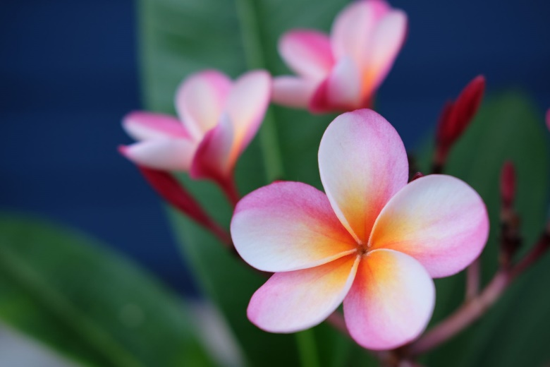  Figure 1: optional caption; style Heading 3;  maximum 2 figures/charts/tables | 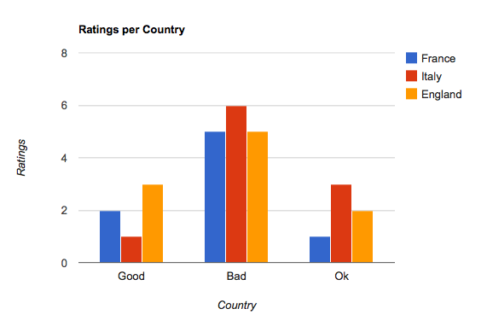  Figure 2: optional caption; style Heading 3;  maximum 2 figures/charts/tables
ADDITIONAL INFORMATION: i.e. funding, research project no. and/or title, acknowledgments etc.
style: Normal; text justified or centered

